
PUCIT
Punjab University College of Information Technology

Lahore Tour Guide
Sprint 1 Report

Table of Contents

SPRINT_1_rEPORT
1 INTRODCUTION 3
2 TEAM 3
3 SPRINT GOAL 3
4 SPRINT OVERVIEW 3
5 BURNDOWN CHART 4
6 SPRINT BACKLOG 4

Introduction
Nowadays, 87% travelers and tourists use navigation apps and smartphones while traveling to new places. Cities across the globe are looking for new ways to offer useful information to tourists and people unfamiliar with the city for a pleasant and guided stay. Many cities have come up with their own apps for the guidance of such people. We aim to develop and design a similar app that will not only give travelers and tourists easy access to the Lahore city’s points of interest. But also allow them to find and book the best place for their stay in the city.

Team
Supervisor: Ma’am Madiha Khalid

Members | Roll no
Maham Mubashir | BSEF17M008
Anzala Mohsan | BSEF17M018
Mubarra Naz | BSEF17M031
Bilal Mubarak (Scrum Master) | BSEF17M056

Sprint Goal
Designing mockups of Lahore Tour Guide app reservation module where using Figma as our design tool. We will configure React Native and create a project and configure our project with Firebase. We will create front end for the designed screens. Further, by using Firebase Firestore, the database structure for our reservation module will be designed. Backend and Queries will also be implemented for respective screens.

Sprint Overview
Planned |  | Completed
Items | Hours | Items | Hours
15 | 200 | 15 | 200

Burndown Chart
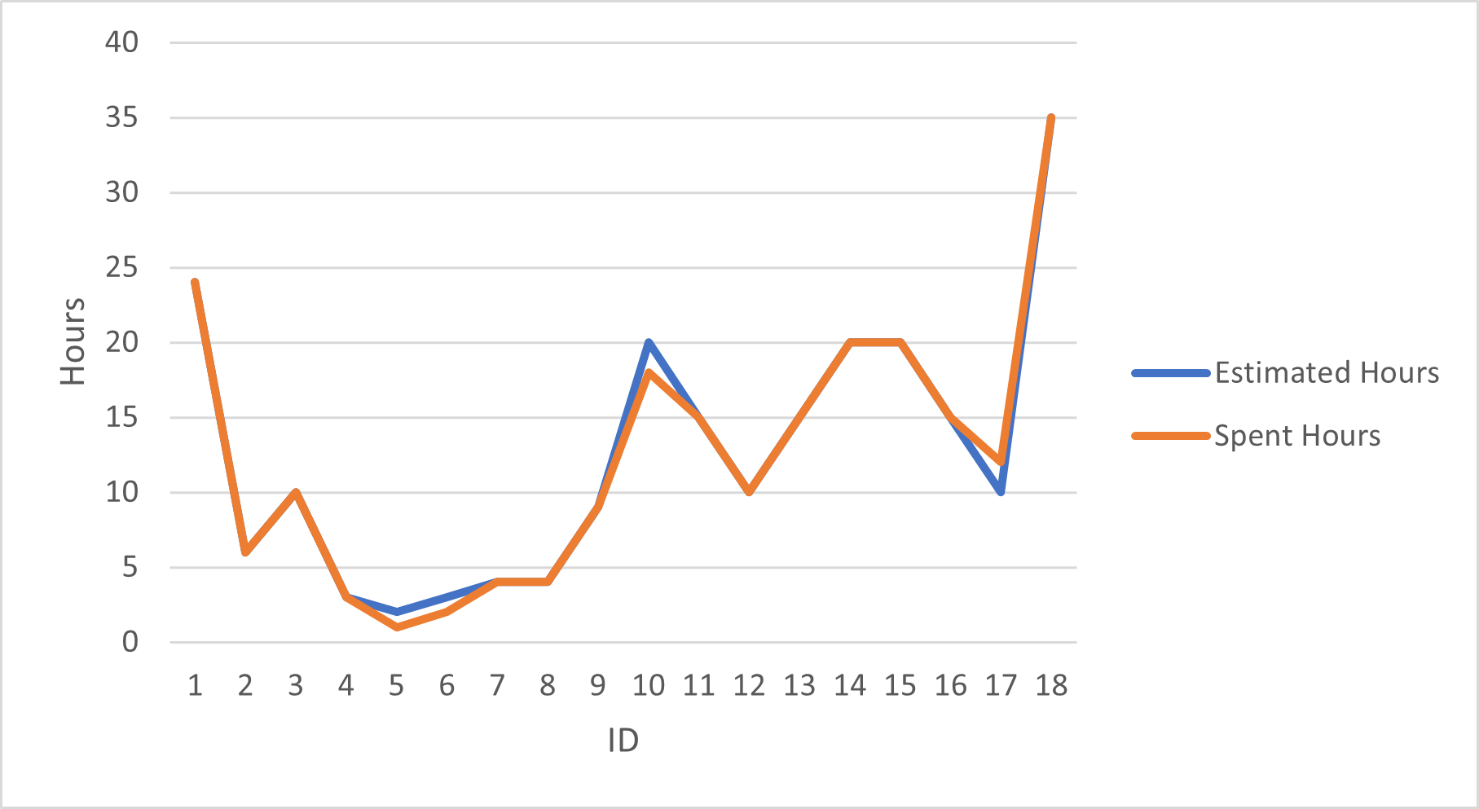

Sprint Backlog
ID | Title | Category | Assigned To | Status | Estimated Hours | Spent Hours
1 | Requirement gathering for sprint | Task | Maham Mubashir  Anzala Mohsan  Mubarra Naz  Bilal Mubarak | Done | 24 | 24
2 | Technical configurations | Task | Maham Mubashir  Anzala Mohsan  Mubarra Naz  Bilal Mubarak | Done | 6 | 6
3 | Meeting related to UI design | help | Maham Mubashir  Anzala Mohsan  Mubarra Naz  Bilal Mubarak | Done | 10 | 10
4 | Login/Signup UI design | Task | Maham Mubashir | Done | 3 | 3
5 | Splash screen UI design | Task | Mubarra Naz | Done | 2 | 1
6 | Home Screen UI design | Task | Mubarra Naz | Done | 3 | 2
7 | Ads Post Screen UI design | Task | Anzala Mohsan | Done | 4 | 4
8 | Edit Profile Screen UI design | Task | Bilal Mubarak | Done | 4 | 4
9 | Meeting related to database design | help | Maham Mubashir  Anzala Mohsan  Mubarra Naz  Bilal Mubarak | Done | 9 | 9
10 | Database structure for reservation module | Task | Anzala Mohsan | Done | 20 | 18
11 | Implemented Splash and Home Screen | Task | Anzala Mohsan | Done | 15 | 15
12 | Implemented Login Screen | Task | Bilal Mubarak | Done | 10 | 10
13 | Implemented Edit profile screen | Task | Maham Mubashir | Done | 15 | 15
14 | Implemented Ads Posting screen | Task | Mubarra Naz | Done | 20 | 20
15 | Implemented Login from Firebase firestore | Task | Bilal Mubarak | Done | 20 | 20
16 | Implemented Edit profile backend | Task | Maham Mubashir | Done | 15 | 15
17 | Implemented Ads post backend | Task | Mubarra Naz | Done | 10 | 12
18 | Meeting related to issues, collaborations and feedbacks | Help | Maham Mubashir  Anzala Mohsan  Mubarra Naz  Bilal Mubarak | Done | 35 | 35

